# ________________________________________________________________

**CSC174 server-side javascript**

________________________________________________________________________

# Unit 02 LAB: A simple loan calculator

# Objectives

In this lab assignment, students will learn:

* To read and write basic JavaScript programs with variables, control structures, functions, and event listeners
* To debug JavaScript code in a browser or IDE of the student’s choice
* To understand fundamental concepts of variables, functions, objects, events, data types, arrays, common JavaScript libraries
* To understand JSON and DOM

# COURSE PREPARATION

You should have done your reading assignment listed under “Reading Assignment” and “Video Assignment” sections in BlackBoard. You should also have reviewed the lecture slides in BlackBoard. There is an optional section called “In Case You Don’t Know” in BlackBoard for those who have limited exposure to JavaScript language.

# WHat to submit

For this lab you need to submit the following files:

* **loan.html (Part One)**
* **Short answer questions sheet (Part Two)**

# grading rubric:

Be sure to follow the Coding Standard Guidelines. You must properly indent and comment your code. This assignment is worth 100 points. 50 points from Part One and 50 points from Part Two.

* Indent code and insert comments to document your program. [5 pts]
* Program must be implemented and run with no syntax errors. [20 pts]
* Program must be implemented and run with no logic errors. [20 pts]
* Required source files should be zipped and uploaded to BlackBoard assignment drop box before the deadline. [5 points]

# ________________________________________________________________

**Part One: A Simple Loan Calculator**

________________________________________________________________________

**Project Description:**

You are given a HTML web page with embedded client-side JavaScript code that calculates and graphs the loan balance, equity and interest payments. (This example is based on the loan calculator example of the book: JavaScript: A Definitive Guide by David Flanagan. I took away the AJAX part that calls a remote PHP script to find lenders who may want to provide the loans.)

The instructor should provide you the source code in ***unit02_lab.zip*** file in BlackBoard Unit 02 Lab sections. There is only one file in this project: ***loan.html***.

When you open the loan.html file in a browser, you should see something like this:

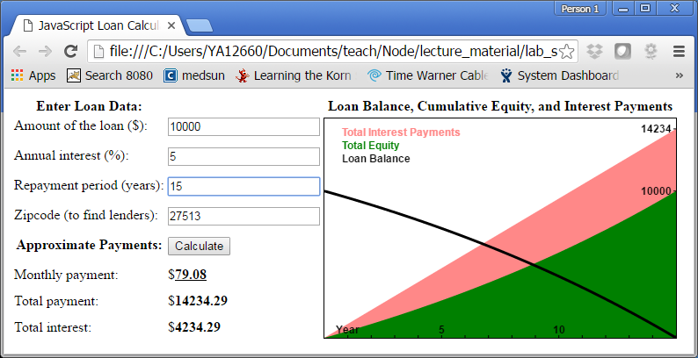

Modify this program so that the annual interest rate is not based on user’s input, but based on user’s credit score. Below is the logic:

|  |  |  |  |  |  |  |
| --- | --- | --- | --- | --- | --- | --- |
| Credit Score | < 400 | >=400  < 500 | >=500  < 600 | >=600  < 700 | >=700  < 800 | >=800 |
| Interest Rate | 10.0 | 8.0 | 6.0 | 4.0 | 3.5 | 3.0 |

After you have modified your program you calculator should look like this:

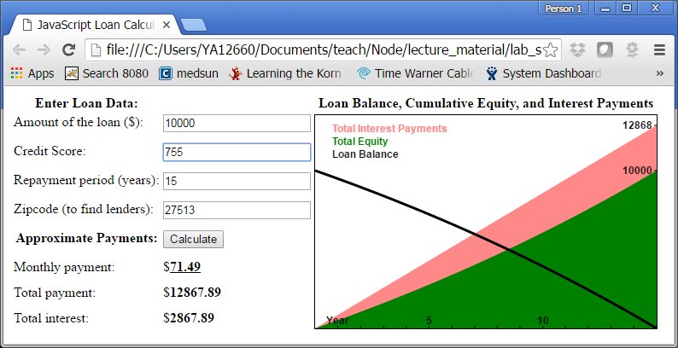

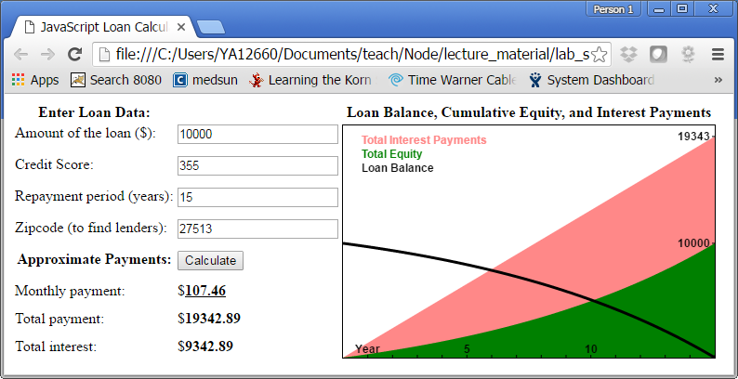

You only need to submit the modified loan.html file.

# ________________________________________________________________

**Part Two: Short answer questions**

*All questions are based on the original loan.html source code provided by the instructor.

Question 1: Where is the JavaScript code located in this program, the head or the body of the HTML document?

The JS is located in the body of this file, though it states that it would normally be located in the head.

Question 2: Is this client-side JavaScript or server-side JavaScript code?

This is server side JS.

Question 3: How many programmer defined functions are there in this program? Please list their names. If it’s an anonymous function write the function definition.

6

calculate()

save(amount, apr, years, zipcode)

window.onload = function()

chart(principal, interest, monthly, payments)

paymentToX(n)

amountToY(a)

Question 4: Do you spy any predefined global objects used in this program? List as many as you know.

window

document

localStorage

Question 5: Do you spy any HTML event registered? If so what type event it is and who is the event handler?

onchange event, handled by calculate()

onclick event, handled by calculate()